XCRAM
Use Case Specification

Submitted to:

Prof. Ma. Rowena C. Solamo
Faculty Member
Department of Computer Science
College of Engineering
University of the Philippines, Diliman

Submitted by:
Agluba, Gerry Jr. P.
Go, Sharleen Joy Y.
Silverio, Robelle C.

In partial fulfillment of academic requirements
for the course
CS 191 Software Engineering I
of the
1st Semester, AY 2016-2017
Unique Reference:
The documents are stored in the [GitHub Repository Link].
[File Reference in GitHub, preferably link.]

Document Purpose:
The purpose of this documentation is to give a description and explain the preconditions, flow of events, postconditions, relationships with other use-cases and special requirements of Use-Case 3.1 Delete Task from Schedule found in the use-case model of the Task Scheduling System.

Target Audience:
Evaluators and Users

Revision Control

History Revision:
Revision Date | Person Responsible | Version  Number | Modification
9/28/16 | Sharleen Joy Y. Go | 1.0 | Initial Document.

Use-Case Name: 3.1 Delete Task from Schedule

Description: The Busy Man actor may delete any task from the current schedule through this use-case. After the selected task is deleted, the resulting schedule is exactly the same as the old one except for the absence of the deleted task.

Preconditions: The task to be deleted must exist in the current schedule.

Flow of Events:
Scenario Name | Description
Scenario 1 (Basic Flow)  A task was deleted from the current schedule. | 1. User selects a task from the current schedule.  2. The task scheduling system asks the question: “Delete the selected task?”  3. User gives a response.  4. If user replies yes, the selected task will be deleted from the current schedule.  5. The task scheduling system displays the resulting schedule.
Scenario 2  No task was deleted from the current schedule. | 1. User selects a task from the current schedule.  2. The task scheduling system asks the question: “Delete the selected task?”  3. User gives a response.  4. If user replies no, the selected task will remain in the current schedule.  5. The task scheduling system displays the unchanged schedule.

Activity Diagram of the Flow of Events:

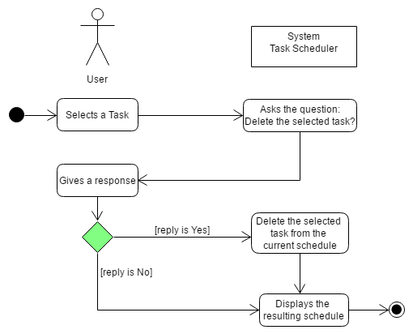

Postcondition: The deleted task must no longer be present in the current schedule.

Relationships: NONE

Special Requirements: NONE

